

<< Date.Verbose >>
VIA USPS

<< Matter.CustomField.OcFirmName >>
<< Matter.CustomField.OcName1 >>
<< Matter.CustomField.OcName2 >>
<< Matter.CustomField.OcName3 >>
<< Matter.CustomField.OcStreetAddress >>
<< Matter.CustomField.OcCityStateZip >>

Re: << Matter.CustomField.CaseNameLong >>,Case No.: << Matter.CustomField.CaseNumber >>

Dear Counsel,

Effective << Date.Verbose >>, Quill and Arrow, LLP will only accept electronic service for all matters pertaining to << Matter.CustomField.CaseNameLong >>, Case No. << Matter.CustomField.CaseNumber >>

If you have any questions or concerns, please do not hesitate to contact us.

Sincerely,
Quill & Arrow LLP

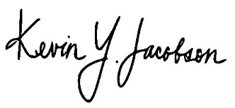
________________________
Kevin Y. Jacobson, Esq.

